**ASSISTED PRACTICE (XML AND XML SCHEMA ASSERTION)**

XML ASSERTION:

Step1: Open Jmeter -> Add Thread Group

Step2: Right click on Thread Group -> Add -> Sampler -> HTTP request

Step3: In HTTP request -> Give protocol as “https” -> Server as “[www.w3schools.com](http://www.w3schools.com)” -> Path as “/xml/note.xml

Step4: Right click on HTTP request -> Add -> Assertions -> XML Assertion

Step5: Right click on Thread Group -> Add -> Listener -> View Results Tree (to see the output) as shown below:

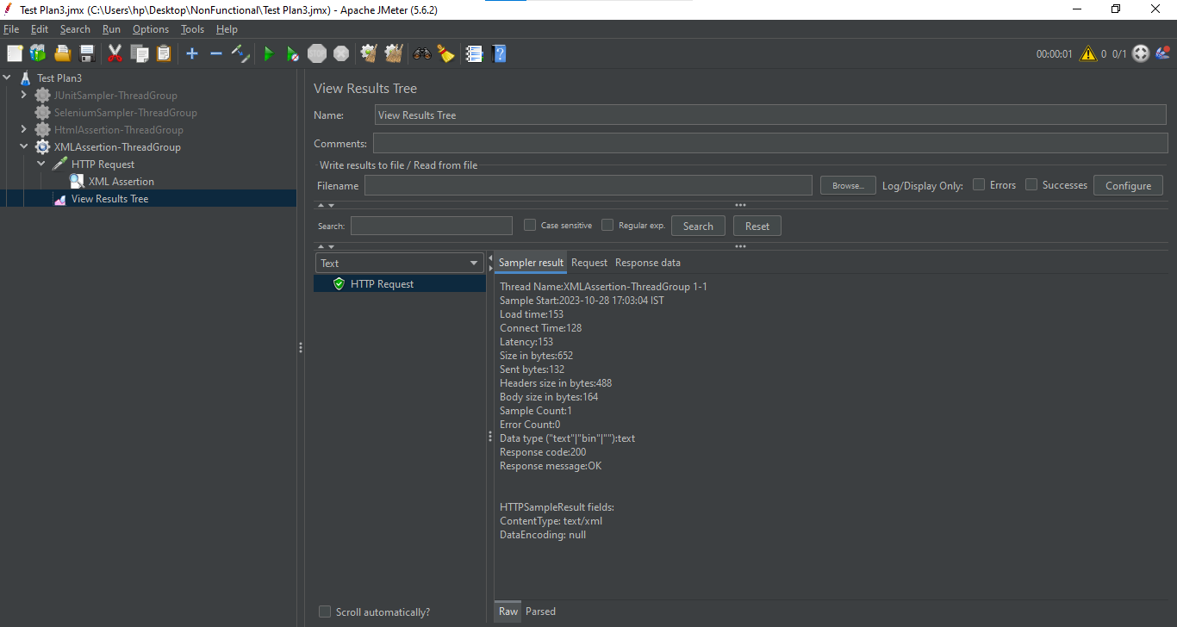

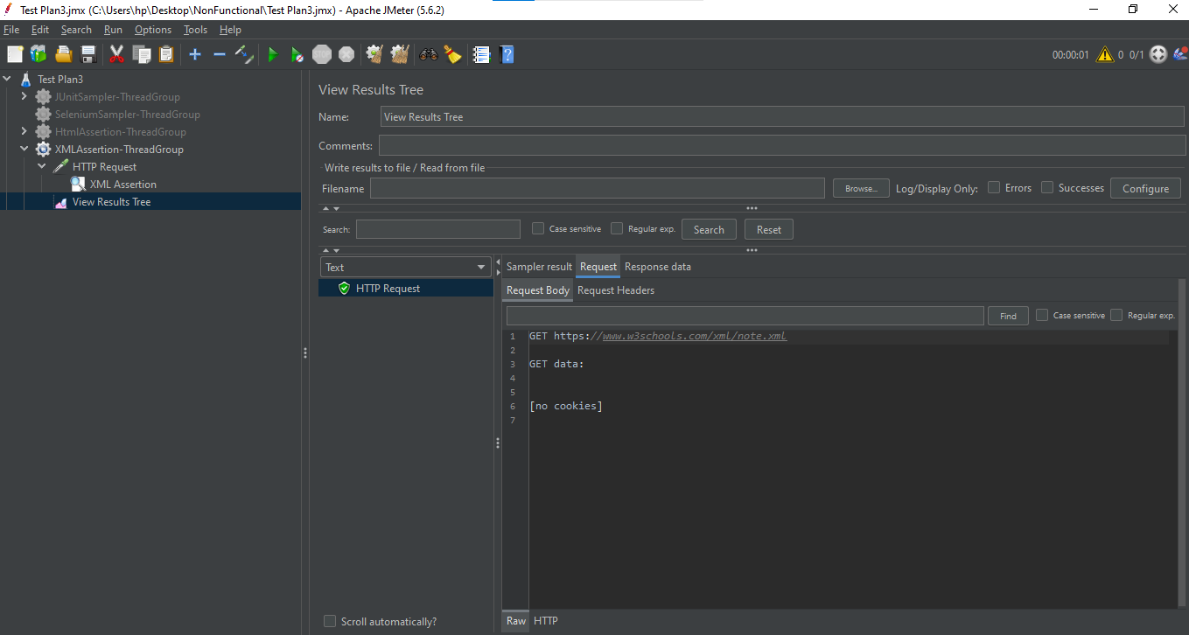

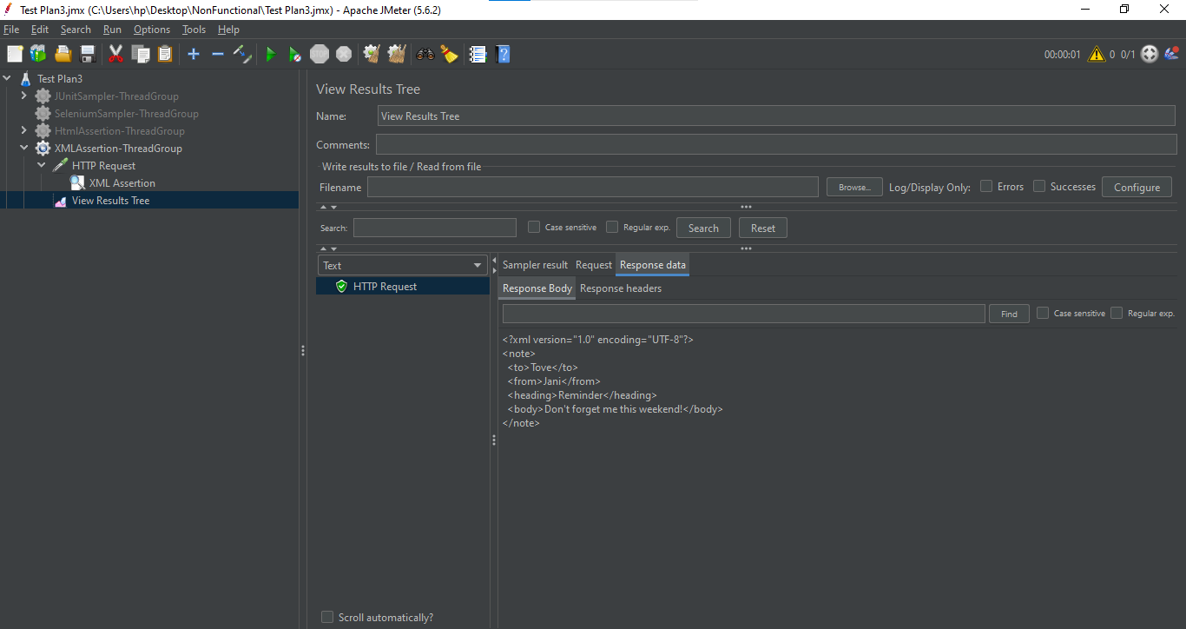

XML SCHEMA ASSERTION:

Step1: Take this xml schema of “www.w3schools.com” website:

<note>

<to>Tove</to>

<from>Jani</from>

<heading>Reminder</heading>

<body>Don’t forget me this weekend!</body>

Step2: Generate this xml schema from xml

Step3: Go to google and search for “Generate xml schema from xml” and press enter

Step4: Select the free online converter for this conversion

Step5: Generate schema

Step6: Take this schema -> Copy in notepad -> Save this file in (our apache jmeter folder -> bin -> examples -> Save the file in this examples folder with the name “sampledemo.xsd”

Step7: Start Jmeter

Step8: Right click on HTTP request that we have created in XML assertion -> Add -> Assertions -> XML Schema Assertion

Step9: Give the complete path of our notepad file (sampledemo.xsd) in XML Schema Assertion -> Save it

Step10: Right click on Thread Group -> Add -> Listener -> View Results Tree (to see the output) as shown below:

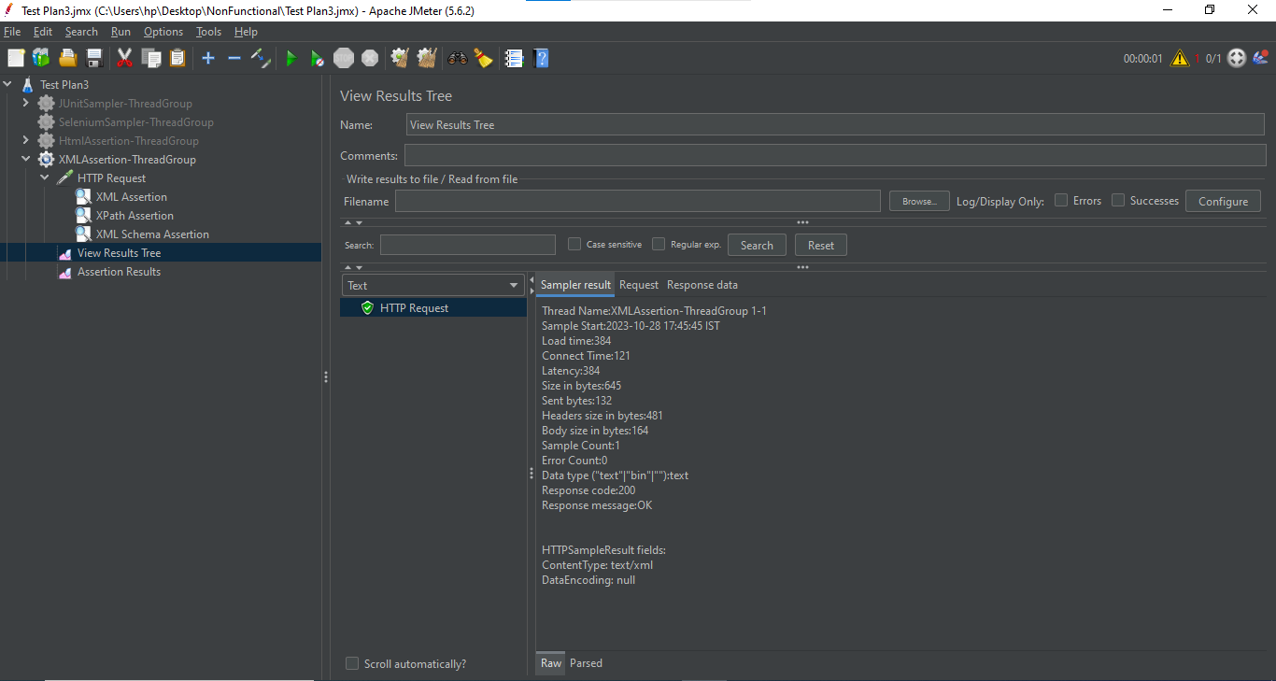

Step11: Right click on Thread Group -> Add -> Listener -> Assertion result (to see the output) as shown below:

